# Welcome to Pet Eligentis website created for people who want to find their ideal pet

Here You can read about how to use Pet Eligentis website to find Your ideal pet weather it is a dog or a cat, register Yourself to be a user of this site and register Your pet as a part of our pet storage.

Pressing on one of two buttons (Pet Elignetis or Home) You can visit home page. If you press on of two images on home page You can visit pet preference pages where you can find the questionnaires. By pressing Sign in button You are going on the page where You can sign in Yourself if You’re already a registered. Clicking the Logout button will end up Your session and you’re not going to be able to visit My Pet page anymore. If You click My Pet button You can visit the page where You can see informations about Your registered pets, and also add or delete pets, but only if You are signed in, if You’re not You’ll be redirected to sign in page. At the bottom of the page below the hyperlinked pictures of dog and cat You can see a two random facts, one for a dog and a cat.

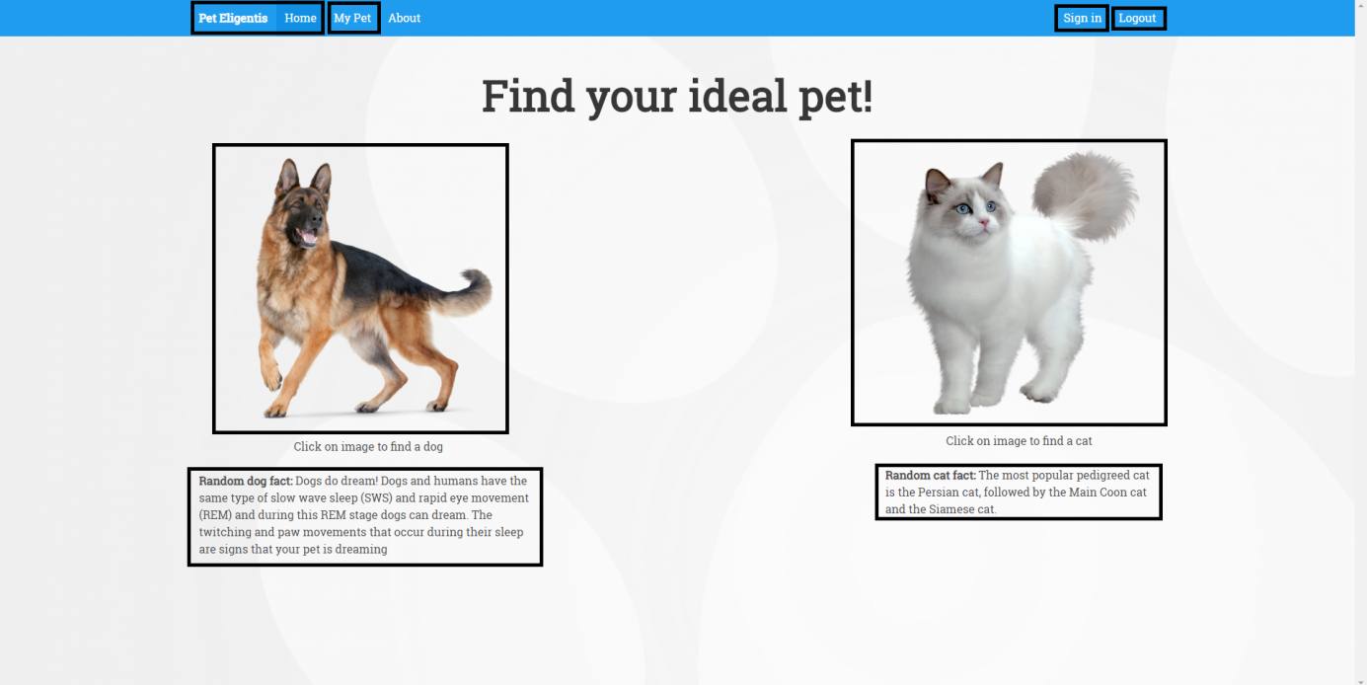

If You press About button you can visit about page where You can see short description of site and its creators.

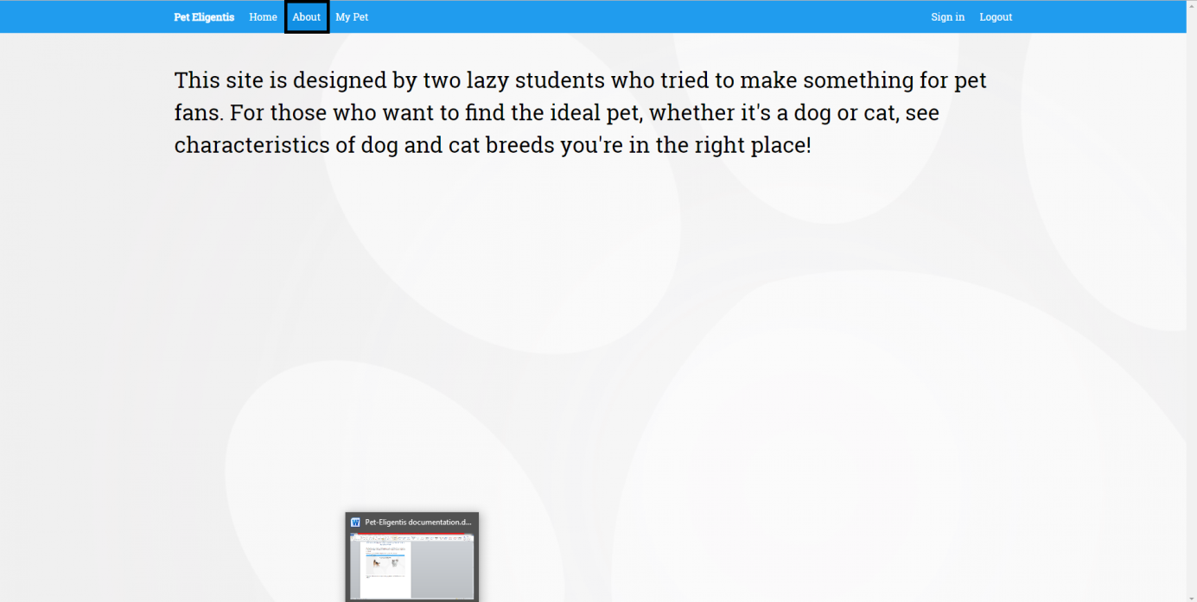

If You click on dog picture on home page You can visit the dog preference page with a couple questions with 1 to 5 scale answers which You need to give and click on submit (Find dog) button in the bottom of the page to see Your ideal dog(s).

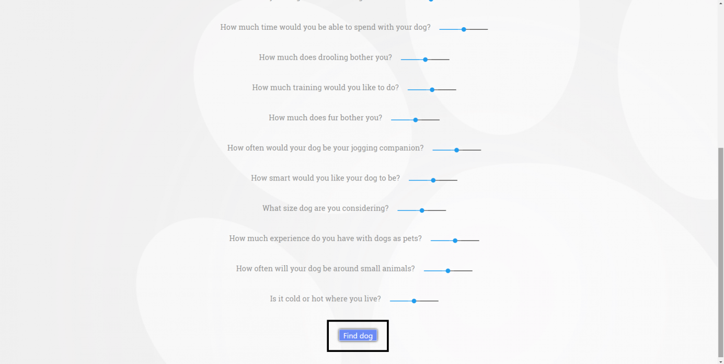

When clicked on cat image on home page You visit the cat preference page with the same type of questions which You need to answer and by clicking submit button (Find cat) You’ll get Your ideal cat(s).

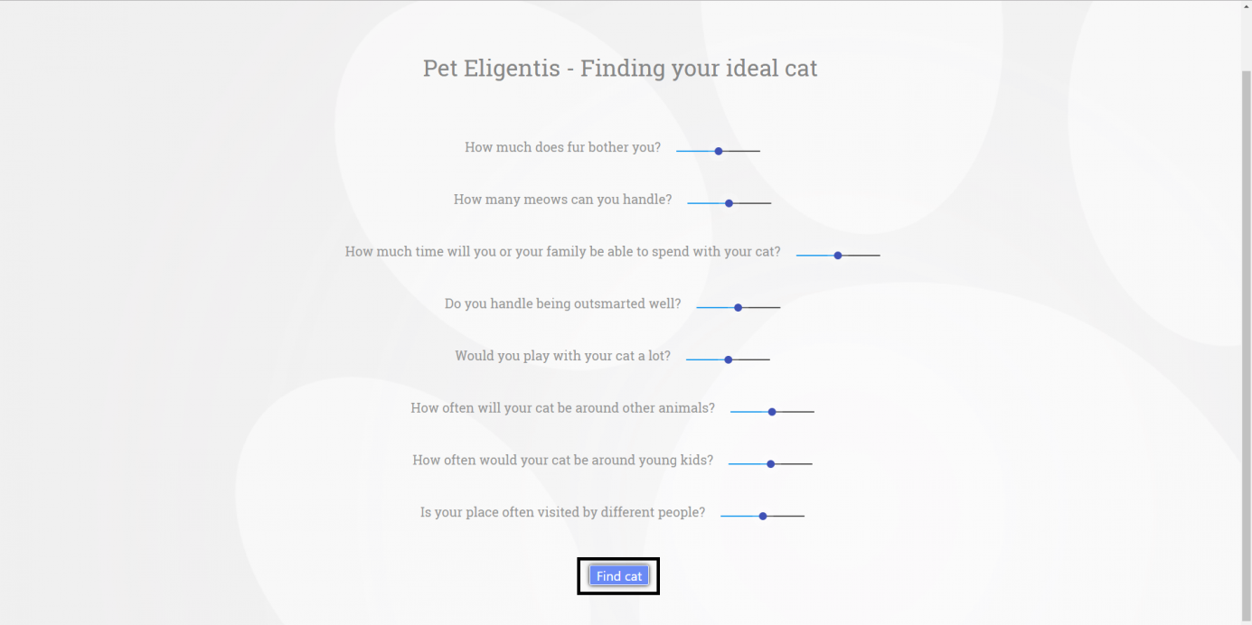

When pressed Sign in button on home page You are going to visit the page on picture below where You can fill the required fields, sign in Yourself by pressing the Log in button and begin Your session on Pet Eligentis site. If You’re not already registered user You can do it by clicking the underlined button Create an account and it will leads You to Sign up page.

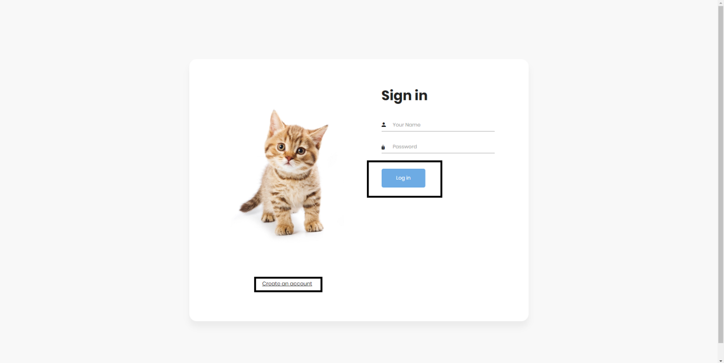

If You visit the Sign up page and You want to create account You can do it by filling the required fields and checking that You agree with the statements in terms of service and then clicking the Register button Your account will be made. After that You’ll be redirected to sign in page where You can login and start Your session on Pet Eligentis site. On the other hand if You’re already member of our site You can press the underlined button I am already member and You’ll be back on sign in page.

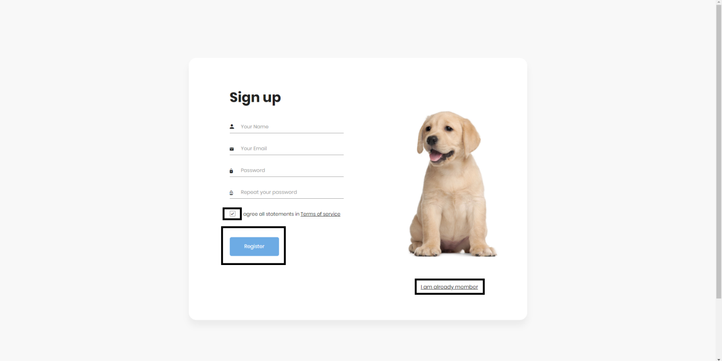

When You click My Pet button in the navigation bar, sign in Yourself if You’re already not, You’re going to visit My Pet page where You can see the table with informations about all Your registered pets. At the same page under the table there are two buttons. One is for adding new pet and the other is for deleting existing one.

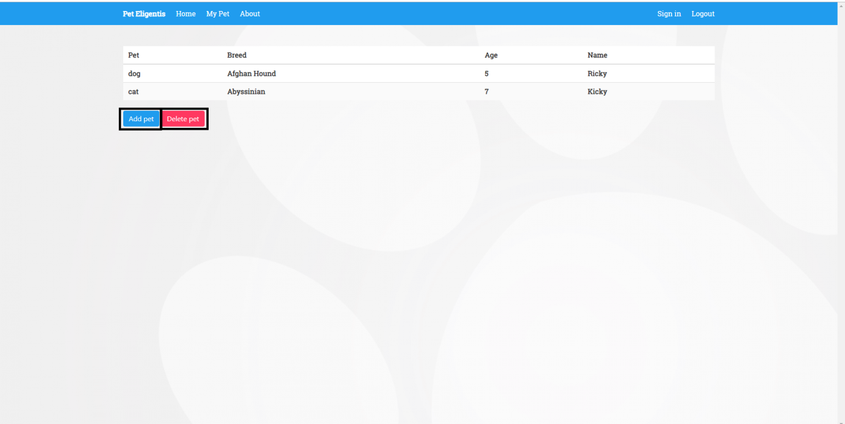

If You press button Add pet on My pet page You’ll see modal page New pet where You can fill in the required fields, and register Your pet by pressing submit (Save changes) button. When You do that Your pet will be registered and afrer that You’ll be back on My Pet page where You can see the informations about Your new pet. If You want to cancel the pet registration You can press the white x button in the upper right corner and leave the new pet page and no changes will be made.

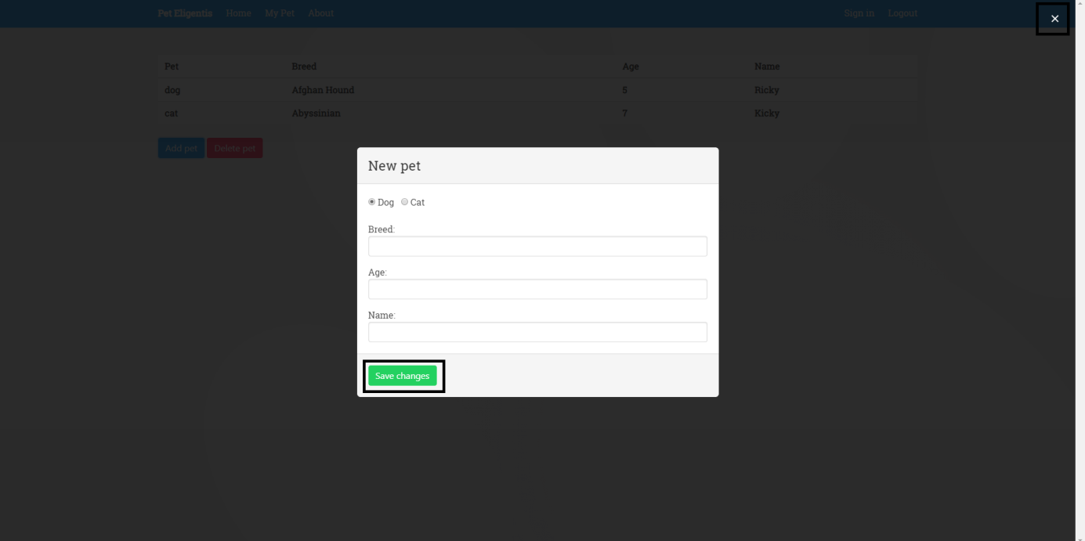

When You decide to delete one of Your pets and press the Delete pet button on My Pet page You’re going to see the modal page for deleting pets with one required text field where You have to write the name of the pet You want to delete. By clicking the submit (Delete) button Your pet will be deleted and when You’ll get back on My Pet page in the pets table there will be no more informations about Your pet. If You change Your mind and give up the deletion of Your pet You can press the white x button in the upper right corner of the page and You’ll be back on My Pet page but no changes will be made on Your pet table.

